**Strengths**

* A self-driven learner with Front-end and Back-end knowledge.
* Ready to learn new technologies and implement them to further improve my knowledge.
* A Team Player with good communication skills always ready to work for the enrichment of knowledge.

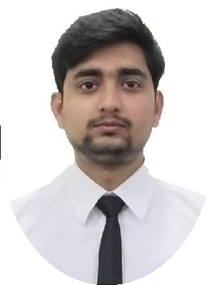

Analyst/Software Engineer

**SUBHASHREE DAKUA DDAKUA**

|  |  |
| --- | --- |
| **Base Location :** | Hyderabad |
| **Email ID :** | SUBHASHREE.DAKUA@CAPGEMINI.COM |
| **Mobile No :** | +91 7849037854 |
| **Grade :** | A4 |

[Check out my work on GitHub](https://github.com/abhijeetkanse)

**Education**

Bachelor of Engineering

(2017 – 2021)

**Training and Certificates**

- Trained in RDBMS domain

- Trained in UNIX/LINUX

- Ethical hacking and Penetration Testing

- C++

**Skills**

SQL

PL/SQL

C++

Shell Scripting

**Additional Details**

Excellent Communication Skills

Team Player

**Achievements / Projects**

**FOOD ORDERING SYSTEM**

Designing a database management system for an organization for evaluation exams using Oracle, Postgre, SQL server database.

**AWS**

Completed aws certification

Presentation Title | Author | Date © Capgemini 2017. All rights reserved | 1